**PROJECT TITLE**

By

**STUDENT NAME1 ROLL NO. 13317002**

**STUDENT NAME1 ROLL NO. 13317002**

**STUDENT NAME1 ROLL NO. 13317002**

(Semester: 4 )

(**Department: Civil Engineering**)

*Submitted*

*In fulfilment of the partial requirements of the project-based learning of a course on Fundamentals of Electronics Engineering.*

*to the*



**BUNDELKHAND INSTITUTE OF ENGINEERING AND TECHNOLOGY, JHANSI**

**(2022-2023)**

**BUNDELKHAND INSTITUTE OF ENGINEERING AND TECHNOLOGY, JHANSI**



**DECLARATION**

We hereby declare that the work which is being presented in this report entitled “**Your Project Title”** . The Information derived from the other sources has been acknowledged in the text and a list of references has been given. We also declare that I have adhered to the ethical norms and guidelines provided by the Institute in writing the report.

**Date:**

**Student Name1 Student Name2 Student Name3**

**Roll No. 13317002 Roll No. 13317002 Roll No. 13317002**

**CERTIFICATE**

This is to certify that the thesis entitled **“Your Project Title”** submitted by above **Student Name1, Student Name2, Student Name3** to the for the subject name of 2nd semester, is carried out by them under my guidance.

**___________________**

**Name Supervisor 1**

Department of Electronics and Communication Engineering

**BUNDELKHAND INSTITUTE OF ENGINEERING AND TECHNOLOGY, JHANSI**



**ACKNOWLEDGEMENT**

It is my great pleasure to acknowledge the support and encouragements I have received from the people along the way to complete this work

Student Names

Date:

**BUNDELKHAND INSTITUTE OF ENGINEERING AND TECHNOLOGY, JHANSI**



**ABSTRACT**

Digital filters are essential component of modern signal processing based electronic devices like mobiles, radios, television, radars etc. Because of their superior performance, digital filters have replaced analog filters in many applications. For applications where stability and linear phase are of prime concern, finite impulse response (FIR) filters are preferred. A proper design approach is necessary for the reliable and effective operation of FIR filter for a particular application. In this regard, a number of filter design approaches have been proposed by researchers to design FIR filters to meet a set of desired specifications in the frequency domain.

**CONTENTS**



INTRODUCTION AND LITERATURE SURVEY 1

1.1 1

1.2 2

1.4.1 Scope 2

1.4.2 Objectives 2

1.3 3

2.1 Review on topic 1 5

2.2 Review on topic 2 5

2.3 Summery of literature review 5

3.1 Introduction 6

3.2 Power Consumption in FIR Filter 6

3.3 Formulation of Low Power FIR Filter Design as an Optimization Problem 7

3.4 Hybrid Artificial Bee Colony Algorithm 8

4.1 Analysis Parameters 9

4.2 results tables and figures 9

4.4 Results and Discussions 9

4.5 Conclusion 12

5.1 Implications of the work on society 14

5.2 Conclusions of the present research 14

5.3 Future Research Directions 15



**CHAPTER 1**

**INTRODUCTION**



* 1. **General Background and Motivation**

Your focused introduction should cover: (1) features of the topic, (2) present status of the field, (3) some unsolved problems, (4) statement of the problem undertaken, and finally (5) importance and justification of the present problem.

Formulation of FIR Filter Design as an Optimization Problem

|  |  |  |
| --- | --- | --- |
|  | $$h={\left[h\left(0\right), h\left(1\right), h\left(2\right),..., h\left(N\right)\right]}^{T}$$ |  |

Similarly, the column vector of complex exponentials can be defined as

|  |  |  |
| --- | --- | --- |
|  | $$e\left(ω\right)={\left[1, e^{jω}, e^{2jω},..., e^{(N)jω}\right]}^{T}$$ |  |

Therefore from (1.2)

|  |  |  |
| --- | --- | --- |
|  | $$H\left(e^{jω}\right)=e^{H}\left(ω\right).h$$ |  |

where $e^{H}\left(ω\right)$ denotes the conjugate transpose of $e\left(ω\right)$. Equation (1.7) represents the relation between filter coefficients and frequency response.

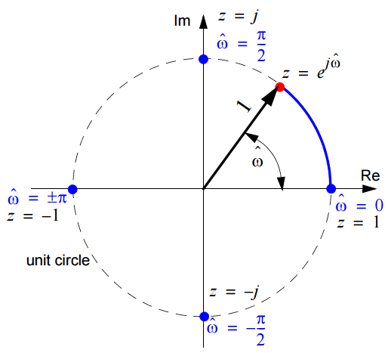

Figure 1.1Circular representation of $H(z)$

Most of the signal processing applications demand filter design with smaller ripple content $(δ)$ in pass band ${(δ}_{p})$ and stop band ${ (δ}_{s})$. Since it is impossible to achieve the characteristics of an ideal filter with finite order, practical filter design techniques aim to achieve a frequency response near to an ideal filter frequency response. The frequency response and specifications for an ideal and practical (designed) filter is depicted in figure 1.2. The cut off frequency, $ω_{c}$ is calculated as

|  |  |  |
| --- | --- | --- |
|  | $$ω_{c}=ω_{p}+\frac{ω_{s}-ω_{p}}{2}$$ |  |

and transition width is calculated as

|  |  |  |
| --- | --- | --- |
|  | $$Δω=ω_{s}-ω_{p}$$ |  |

Considering the advantages, wide applications and existing design challenges of FIR filter, the present work is motivated by thefact that a properly designed FIR filter (one dimensional or two dimensional) should not onlypossess proper frequency domain characteristics, but also dissipate less power when implemented in hardware. This has been outlined in the next section in terms of scope and objectives of the research.

* 1. **Scope and Objectives of the Research**

**1.4.1 Scope**

The literaturesurvey in the previous section reflects that a good development has taken place in evolutionary optimization based FIR filter design. Most of the evolutionary optimization based techniques discussed in the literature review have concentrated on minimizing the ripples in pass band and stop band.

**1.4.2 Objectives**

Based on the literature survey and the scope outlined in the previous section, the following objectives are framed for the present research

1. To formulate FIR filter design as an optimization problem and solve it using an evolutionary optimization technique, which provides convergence to the global optima with reduced computational cost.
2. To design a filter that achieves the desired frequency domain characteristics and minimizes power consumption during filter execution.
3. To propose a multi-objective optimization based FIR filter design approach that allows the user to select a particular filter from a solution set based on priority of objectives and application.
4. To design a low power two dimensional FIR filters for image processing applications using a modified two dimensional version of the optimization techniqueproposed for objective1.
5. To analytically prove convergence of the optimization techniques used for achieving the objectives 1-4.
6. To implement the filters designed using the approaches in objectives 1-4 using FPGA and validate the real time applicability of the designed filters in terms of achieving the frequency domain specifications and power consumption.
   1. **Outline of the Thesis**

The organization of the remaining Chapters of the thesis is as follows: In C**hapter 2**, the FIR filter design task has been formulated as an optimization problem with the aim of meeting frequency domain specifications related to PBR, SBR and transition width. To overcome problems related toslower convergence(larger execution time) andtrapping into the local optimal solution of conventional ABC algorithm, two improvements have been proposed in the algorithm. The convergence of the proposed modified ABC algorithms has been proved analytically. In addition to the anaytical proof, the algorithms the effectiveness of the algorithms has been proved numerically by comparing the solution obtained by other metaheuristic techniques on a set of standard benchmark functions. Further the efficacy of the proposed technique in meeting the filter specifications has also been evaluated and compared with reported evolutionary algorithms and non-convex optimization techniques.

Motivated by the requirements of low power FIR filter, in **Chapter3**the filter design task aims at satisfying the dual objectives of meeting the desired frequency domain specifications and power minimization, using the hybridization of a local search technique(Nelder-Mead optimization) with classical ABC algorithm. The first objective is met by reducing the deviation in frequency response between the designed and ideal filter. Power minimization has been achieved by minimizing the transitions in filter coefficients in terms of the Hamming distance. The effectiveness of the proposed algorithm has been validated by designing filters for varying specificationsand analyzing power consumption using Xilinx X-power analyzer.

A multi-objective optimization based FIR filter design approach has been presented in **Chapter 4**, which takes into accountall the possible trade-offs between the competing multiple objectives. The problem regarding the selection of Lagrange’s multiplier to assign weightages to multiple objectives has been overcome using the proposed modified version of classical multi-objective ABC algorithm.

In**Chapter 5,** a modified ABC algorithm has been proposed for the design of low power 2D FIR filters. The objective function for the optimization problem has been framed using singular value decomposition and hamming distance.

The evaluation is carried out in terms of pass band and stop band ripple minimization, convergence profile and power consumption during filter execution in hardware. **Chapter 6** outlines the significant conclusions of the present work. In addition, some future research directions on the possible extension of the work are presented.



**CHAPTER 2**

**REVIEW OF RELATED WORKS**



**2.1 Review on topic 1**

Digital filters are widely used in different electronic devices like mobiles, computers, radios, wireless systems and AV systems. Accuracy, linear phase, inherent stability, suitability

**2.2 Review on topic 2**

As mentioned earlier, optimization based filter design techniques seeks either to achieve a frequency response near to an ideal filter response or to meet a set of specifications. The objective function for optimization based FIR filter design problem is quantified in terms of the error in frequency response of the designed filter and desired specifications. The various objective functions reported for FIR filter design have been reviewed in section 1.2. In optimization based filter design techniques, the error between the ideal frequency response and designed filter response is reduced by iteratively updating the coefficients. The type of errors involved in objective functions can be broadly classified into complex error [1–4], absolute error [5–8] and logarithmic error [9]. The classification of the reported error (objective) functions is summarized in figure 2.1.

**2.3Summery of literature review**

reported on the application of heuristic optimization for FIR filter design have not concentrated on the minimization of transition width with faster pass band to stop band transition.



**CHAPTER 3**

**METHODOLOGY**



**3.1 Introduction**

In the previous Chapter, FIR filters were designed with the sole aim of achieving frequency domain specifications. Motivated by the fact that a properly designed FIR filter, should not only possess proper frequency response but also consume less power when implemented in hardware, in this Chapter, FIR filters have been designed, which in addition to maintaining the desired frequency domain specifications, also dissipate low power during execution. In many signal processing systems, FIR filters consume high power because of the high operating frequency and high device count. The high power consumption causes adverse heating effects, increases cooling and packaging related cost. These factors alongwith the recent growth witnessed in the demand of low power consumption based portable or remotely operated devices,have accelerated the development of low power algorithms for DSP systems [11–19].

The next section discusses the power consumption in FIR filters. Low power FIR filter design has been formulated as an optimization problem in section 3.3. The proposed Hybrid Artificial Bee Colony Algorithm (HABC) and its convergence has been discussed in section 3.4. Section 3.5 discusses the results obtained and finally section 3.6 concludes the Chapter.

**3.2 Block Diagram**

Digital filters are generally implemented using CMOS based digital hardware [12,15,19–22]. The power consumption of a FIR filter depends on power consumption in the fundamental building block of FPGA, *i.e.* CMOS inverter. The overall power consumption of a CMOS circuit is composed of three components,*i.e.* switching , short circuit and leakage power [23]. The short circuit power, which generally consumes less than 10% of the total power in properly designed circuits results from the flow of short circuit current during the transition between the complementary signals. Similarly, the leakage power results from the leakage currents, which is in the order in pico-amperes and hence is not a major component of the overall power consumption. Power consumption arising out of switching currents is an important component, especially at high frequencies. The switching currents occur because of the charging and discharging of the output capacitors. The switching power is represented as

|  |  |  |
| --- | --- | --- |
|  | $$P_{switch}=α_{0↔1}C_{L}V_{DD}^{2}f_{clk}$$ |  |

where $α_{0↔1}$ is the node transition activity factor, representing the probability with which the circuit node changes from 0 to 1 or vice versa, $C_{L}$ is the load capacitance, $V_{DD}$ is the supply voltage and $f_{clk}$ is the operating clock frequency.

Equation (3.4) reflects the overall switching in terms of the binary values of the successive coefficients of the filter. For a filter having similar coefficients resulting from low switching activity, the HDs [$H(Coef_{i}, Coef_{i+1})$] and hence the power consumption will be low. The present Chapter aims at deriving filter coefficients that minimizes the switching power by carrying out a search for the coefficients that minimizes $J_{power}$. The formulation of a low power FIR filter design task as a search based optimization problem, is discussed in the next section.

**3.3 Formulation of Low Power FIR Filter Design as an Optimization Problem**

In this section, the low power FIR filter design task has been formulated as an optimization problem and further solved using the proposed HABC algorithm. As mentioned earlier, a properly designed FIR filter should not only possess a proper frequency response but also dissipate less power during execution in hardware. To achieve the same, the filter design task has been framed as an optimization problem by considering a single objective function with two components, *i.e.* attaining desired frequency response and power consumption minimization, combined using a Lagrange multiplier. The objective function is given as

|  |  |  |
| --- | --- | --- |
|  | $$J=J_{freq}+λ×J_{power}$$ |  |

where $λ$ is the Lagrange multiplier, $J_{freq}$ and $J_{power}$ represents objective function related to frequency and power consumption in terms of HD (3.4) respectively. The Lagrange multiplier allows incorporating two dimensionally different objectives, by considering the second objective,*i.e. ${ J}_{power}$* as a constraint with a weightage, given by the Lagrange multiplier. For a given iteration $k$, the Lagrange multiplier is given as

|  |  |  |
| --- | --- | --- |
|  | $$λ(k)=\frac{J_{freq}(k-1)}{J_{power}(k-1)}$$ |  |

The formulation of objective function related to PBR and SBR has been discussed in section 2.2. In addition to ripples and power consumption, another important consideration in FIR filter design is transition width. By including a component for the desired transition width $(T_{d}),$ the objective function (2.3) is modified as

|  |  |  |
| --- | --- | --- |
|  |  |  |

where $T$ represents the number of samples in the desired transition width. All other notations as mentioned in Chapter 2have been followed. To solve the computationally intensive objective function (3.5) for low power FIR filter design, a hybrid optimization based algorithm has been used by combining ABC algorithm with NMSS. The proposed HABC algorithm has been discussed in the next section.

**3.4 Flow Chart of the Project**

As discussed in section 2.4 of Chapter 2, artificial bee colony algorithm (ABC) [24,25] is a relatively new swarm optimization based algorithm, which replicates the intelligent information sharing behaviour of honey bees about the nectar amount available in the food sources. ABC algorithm has been widely used for various engineering optimization problems [26–29]. The algorithm has been successfully used in civil [30], control [31], Electronic and Telecommunication[32], electronics [33], mechanical [34] and industrial



**CHAPTER 4**

**RESULTS AND PERFORMANCE ANALYSIS**



**4.1 Analysis Parameters**

While designing FIR filters for various specifications, it has been observed in the last two Chapters that minimization in PBR, SBR and power consumption cannot be achieved simultaneously. In this regard, a novel approach for FIR filter design has been proposed in the presentChapter using multi-objective optimization. A common limitation with most of the existing optimization based FIR filter design techniques is that they aim at meeting a specific objective and when designed with a given objective, they perform poorly with respect to the objective not considered during the design. The design is governed by the application, where the filter has to be used. For DSP applications like high

**4.2 Results Tables and Figures**

This section discusses the framing of FIR filter design task as a multi-objective

iteration. The EA obtained after satisfying optimization criterion is referred as Pareto optimal front. From (4.16) and (4.34), it can be observed that after few iterations, there will be an improvement in the fitness albeit with lesser diversity, *i.e.* there is probability of the solution converging to local optima. However, the diversity in population is maintained by employing scout bees. The updation of scout bee location using (4.15) leads to large perturbation in the current location. With the assumption that scout bees properly explore the search space, the global convergence of the proposed M-MOABC algorithm can be ensured.

**4.4 Results and Discussions**

The effectiveness of the proposed M-MOABC algorithm for the design of FIR filters has been evaluated in this section. The evaluation has been carried out in three stages. In the first stage, its performance has been evaluated in terms of frequency response, *i.e.*minimization of PBR (4.3) and minimization of SBR (4.4). Further an additional objective has been added in the second stage for minimizing power consumption (4.10). Finally, in the third stage, the filters designed using the proposed algorithm has been implemented in hardware using FPGA. For selection of the M-MOABC control parameters a large number of pilot runs with different settings were executed, based on which the bee colony size and scout bee limit has been selected as 100 and 20 respectively.

To compare the proposed technique with other state of the art metaheuristic multi-objective algorithms, the design of a low pass FIR filter is attempted using the following specification: normalized pass band frequency = 0.45 rad/s , normalized stop band frequency = 0.55 rad/s, normalized PBR = 0.01, normalized SBR = 0.01and filter length = 21. For comparison, both the proposed M-MOABC and the conventional MOABC algorithm is executed for the same number of function evaluations,*i.e.* 2000. The frequency responses of the designed filters have been simulated using MATLAB/SIMULINK 8.5 and further implemented in hardware (FPGA) using Xilinx ISE 14.7. After implementation, the power consumed during filter execution is analyzed using Xilinx X-Power analyzer. Following initialization with a set of possible random solutions (filter coefficients), they are iteratively updated with the aim of minimizing all the objectives. Figure 4.3 represents the Pareto front obtained post convergence of M-MOABC and MOABC with two objectives, *i.e. $f_{1}$*(4.3) and ${ f}_{2}$ (4.4). Every solution in the Pareto front represents a filter, with each filter maintaining a trade-off between minimizing ripples in pass band and stop band.The ability of the proposed technique M-MOABC in providing dominating solution as compared to the conventional MOABC is clearly reflected in figure 4.3.The coefficients of the three prototype filters (solution) from the Pareto front are depicted in table 4.1.

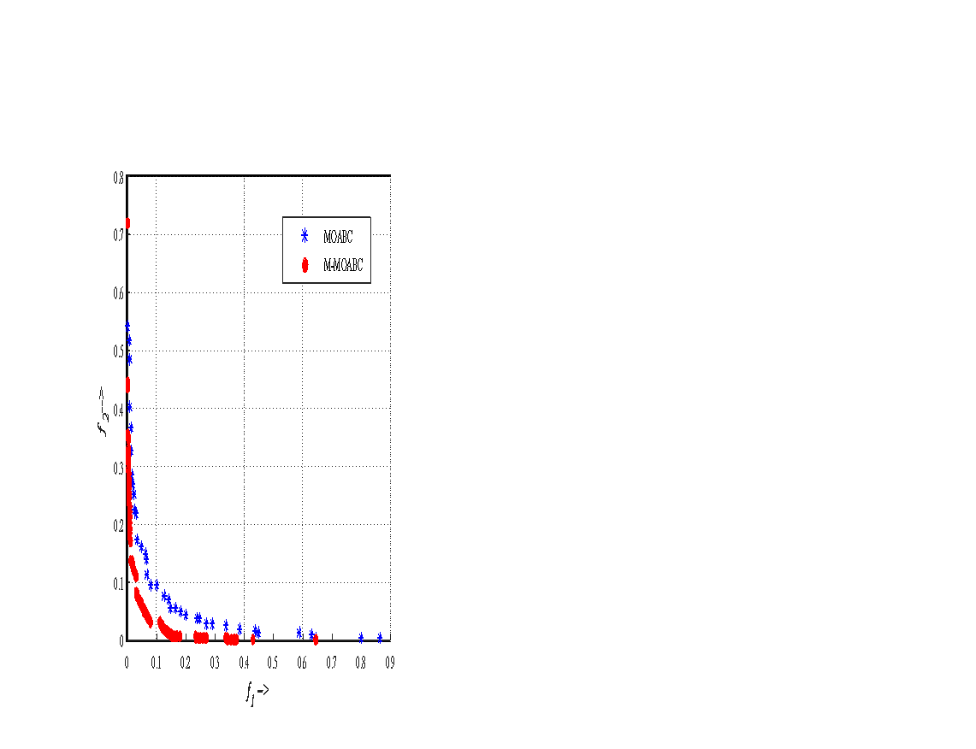

1. Pareto front obtained for LPF using MOABC and M-MOABC

For each algorithm, the first filter provides minimum PBR, the second minimum SBR and third maintains a trade-off between PBR and SBR by minimizing both PBR and SBR. FIR filters with low PBR is useful for cases where reducing ripples is the only concern. These include applications like speech processing, Hilbert transformer and communication. However, for signal noise removal, ECG denoising, image enhancement attaining less ripples in stop band is of prime concern. Similarly in applications like vibration signal & music signal, filters with trade-off between PBR and SBR are preferred. The frequency responses of the filters for the three cases are shown in figure 4.4 and compared with the frequency responses of the respective filters obtained using the classical MOABC, MODE, MOPSO and NSGA-II.

1. Comparison of the proposed M-MOABC with other evolutionary multi-objective algorithms

|  |  |  |  |  |  |  |  |  |  |  |  |  |
| --- | --- | --- | --- | --- | --- | --- | --- | --- | --- | --- | --- | --- |
| Parameters  Technique | Minimum $(f_{1})$ | | | Minimum $(f_{2})$ | | | Minimum $(f_{3})$ | | | Trade-off ( $f_{1}, f_{2}, f_{3})$ | | |
| PBR | SBR | HD | PBR | SBR | HD | PBR | SBR | HD | PBR | SBR | HD |
| NSGA-II | 0.051 | 0.2243 | 8.23 | 0.521 | 0.037 | 8.34 | 12.01 | 6.121 | 3.89 | 0.111 | 0.162 | 6.13 |
| MOPSO | 0.039 | 0.1865 | 8.51 | 0.492 | 0.021 | 8.72 | 11.01 | 6.951 | 4.41 | 0.123 | 0.141 | 7.11 |
| MODE | 0.043 | 0.1853 | 8.56 | 0.533 | 0.019 | 8.61 | 06.04 | 8.021 | 3.32 | 0.071 | 0.073 | 5.91 |
| MOABC | 0.041 | 0.1479 | 9.13 | 0.426 | 0.019 | 8.66 | 7.825 | 7.635 | 0.15 | 0.065 | 0.064 | 6.26 |
| M-MOABC | 0.014 | 0.2029 | 8.38 | 0.637 | 0.014 | 8.75 | 12.05 | 6.93 | 0.12 | 0.041 | 0.040 | 4.64 |

Like previous Chapter, to test the appropriteness of the propoed technique for real time applications, the filters designed have been implemented using virtex-7 FPGA. The power consumed during filter execution has been analyzed using Xilinx X-power analyzer. The power consumption using the proposed algorith has been compared with the MOABC in table 4.5. The effect of inclusion of objective function $f_{3}$ is clearly observed in the form of reduction in power consumed during filter execution.

1. Comparison of power consumed during filter execution

|  |  |  |  |  |  |
| --- | --- | --- | --- | --- | --- |
| Algorithm  Filter | MOABC | | | M-MOABC | |
| HD | PC (mW) | HD | | PC (mW) |
| Table_4.1_Min $f_{1}$_ | 8.51 | 0.08 | 8.53 | | 0.07 |
| Table_4.1_Min $f_{2}$_ | 7.23 | 0.07 | 9.1 | | 0.08 |
| Table_4.1_Min $f_{1}$_& $f_{2}$ | 8.24 | 0.09 | 8.5 | | 0.06 |
| Table_4.3_Min $f_{1}$_ | 9.13 | 0.11 | 8.38 | | 0.06 |
| Table_4.3_Min $f_{2}$_ | 8.66 | 0.10 | 8.75 | | 0.07 |
| Table_4.3_Min $f_{3}$_ | 0.15 | 0.03 | 0.12 | | 0.03 |
| Table_4.3_Min $f_{1}$_& $f_{2}$& $f_{3}$ | 4.64 | 0.04 | 6.26 | | 0.05 |

From the results discussed in this section, it is clear that the proposed M-MOABC is an excellent optimizer for low pass filter design. As an extension of the work, the algorithm can be used for designing high pass filter, band pass filter, band stop filters using the desired responses represented by (4.7), (4.8) and (4.9) repectively.

**4.5 Conclusion**

Unlike the existing works on optimization based FIR filter design, which have only concentrated on minimizing ripples using single objective optimization approach, in the present work, reduction in power loss has also been included as one of the objectives. The dynamic power consumption has been quantified in terms of its dependency on switching activity. The filter design task has been formulated as a multi-objective optimization problem and solved using a modified version of the classical multi-objective ABC algorithm. The modified algorithm improves the convergence profile by exploiting the iterative search behaviour and convergence history. Unlike the filter design approaches discussed in Chapter 2 and 3, *i.e.* using modified ABC algorithm and HABC algorithm, the use of multi-objectives allows one to select a filter from a set of filters based on requirements and/or application. The effectiveness of the proposed approach for filter design has been validated by comparing its performance with MOABC and other multi-objective metaheuristic techniques. The proposed approach is found to outperform other techniques for a given filter order. The trade-off observed between minimizing ripples and power consumption justifies the use of multi-objective optimization for the present problem. In addition to the simulated frequency response analysis, the effectiveness of the proposed technique has also been validated experimentally.

In the present as well as the last two Chapters, one dimensional FIR filters have been designed. The proposed approaches are found to be efficient for low pass filter design. It has been established in the reported works that the approaches which performs well for low pass filter also performs satisfactorily for high pass, band pass and band stop filters [7,35,36]. The filters design approaches reported in these Chapters can be utilized for one dimensional signal (biomedical signal, vibration signal or any other signal) separation, restoration and denoising application. For the applications related to two-dimensional signal processing especially image applications, the proposed one dimensional filter design approaches are extended to two-dimensional filter design in the next Chapter.



**CHAPTER 5**

**CONCLUSION**



**5.1 Implications of the work on society**

In the last three Chapters, one dimensional FIR filters have been designed using metaheuristic optimization approaches. Motivated by wide application of Two Dimensional (2D) digital filters in diverse areas like image processing [37], seismic signal processing [38,39], nuclear test detection, sonar, radar and radio astronomy [40], in this Chapter, a metaheuristic optimization based 2D FIR filter design approach has been proposed. In the area of image processing, 2D FIR filters are preferred because of their inherently stable nature, no phase distortion and easy realization using Fast Fourier Transform (FFT). In image applications, they are used for image contrast enhancement, denoising [41,42], image de-blurring and image restoration [43]. For 2D FIR filter design, the classical techniques of 1D FIR filter design techniques which have been extended to 2D domain include windowing techniques [44], frequency sampling approach [45], Chebysev approximation [46] method, McClellan transformation method [40]and least squares [47]. Though windowing is the simplest technique for magnitude response but it fails in providinglinear phase [44]. In addition to the classical techniques mentioned above, optimization based approaches have also been successfully applied for the design 2D FIR filters[41,48–59].

**5.2 Conclusions of the present research**

Unlike the formulation of objective function for 1D FIR filter design discussed in the previous Chapters, where the deviation in frequency domain is represented by a vector and quantified using $l_{p}$ norm or Chebysev minimax approximation, for 2D filters, the deviation takes the form of a matrix. Hence the approaches proposed for 1D filter cannot be directly applied in higher dimensional objective space. Conventionally, optimization

(c)

With the aim of extending the proposed filter design approach to 2D FIR filters, the optimization problem formulation in 2D space, has been carried out using singular value decomposition. This allows reducing the computational complexity of the multidimensional problem. The performance of proposed modified ABC algorithm has been validated for a wide range of shapes (*i.e.* circular, rectangular, diamond and elliptical) and specifications of 2D FIR filters. The designed filters have been successfully applied for image denoising applications.

The convergences of all the proposed optimization techniques have been proved analytically. The designed filters have been validated for real time applications using Virtex-7 (device-xc7vx485t-2ffg1761) FPGA. The comparative analysis reveals that lesser hardware complexity is required in filter implementation using the proposed implementation architecture.

**5.3 Future Research Directions**

In continuation with the aim of designing digital FIR filters for wider range of specifications and applications, the future research in this direction would be focused on the following areas

* The designed filters have been implemented using FPGA. The comparison with the simulated frequency response reflects the effect of quantization error, parasitic and inherent delays on the filter characteristics, the filter design approach can be further extended by incorporating and optimizing the real time operation parameters of FPGA in the objective function.
* A low power FIR filter design approach has been proposed by reducing switching activity between filter coefficients. The switching activity reduction can be used in other designs based on CMOS implementation. For solving the computationally intensive optimization problem HABC algorithm has been proposed. The proposed HABC algorithm can be used for other non-convex, multi-model engineering optimization problems. HABC can also be used for low power FIR filter design using sparse, CSD representation of FIR filter coefficients.



**REFERENCES**

[1] B. Luitel, G.K. Venayagamoorthy, Differential evolution particle swarm optimization for digital filter design, in: 2008 IEEE Congr. Evol. Comput. (IEEE World Congr. Comput. Intell., IEEE, 2008: pp. 3954–3961. doi:10.1109/CEC.2008.4631335.

[2] K. Boudjelaba, F. Ros, D. Chikouche, Potential of Particle Swarm Optimization and Genetic Algorithms for FIR Filter Design, Circuits, Syst. Signal Process. 33 (2014) 3195–3222. doi:10.1007/s00034-014-9800-y.

[3] G.L.G. Liu, Y.L.Y. Li, G.H.G. He, Design of digital FIR filters using differential evolution algorithm based on reserved genes, in: IEEE Congr. Evol. Comput., IEEE, 2010: pp. 1–7. doi:10.1109/CEC.2010.5586425.

[4] L. Cen, Ã. Ling Cen, L. Cen, A hybrid genetic algorithm for the design of FIR filters with SPoT coefficients, Signal Processing. 87 (2007) 528–540. doi:10.1016/j.sigpro.2006.06.015.

[5] A. Lee, M. Ahmadi, G. Jullien, W.C. Miller, R.S. Lashkari, Digital filter design using genetic algorithm, in: 1998 IEEE Symp. Adv. Digit. Filter. Signal Process. Symp. Proc. (Cat. No.98EX185), IEEE, 1998: pp. 34–38. doi:10.1109/ADFSP.1998.685690.

[6]